**NAME :- PANCHAL VRAJ GAUTAMKUMAR**

**EN NO :-2401030430029**

**ROLL:- 3CE-D-054**

**TOPIC :- HOME DECOR**

**Home Decor – Redefine Your Living Space with Elegance**

**Welcome to Home Decor!**

Your home is more than just a place to live—it’s a reflection of your personality, lifestyle, and comfort. At **Home Decor**, we bring you the finest home decor inspirations to help you create a space that resonates with your style. Whether you’re looking to transform your home with modern aesthetics, add warmth and coziness, or infuse luxury into your interiors, we have everything you need to make your dream home a reality.

**Why Choose Home Decor?**

**1.Exclusive Home Design Inspirations**

Discover a wide range of stunning home decor ideas, from **minimalist and contemporary styles** to **classic and traditional interior designs**. Our platform offers a meticulously curated collection of themes and inspirations that help you bring harmony, sophistication, and functionality to your home.

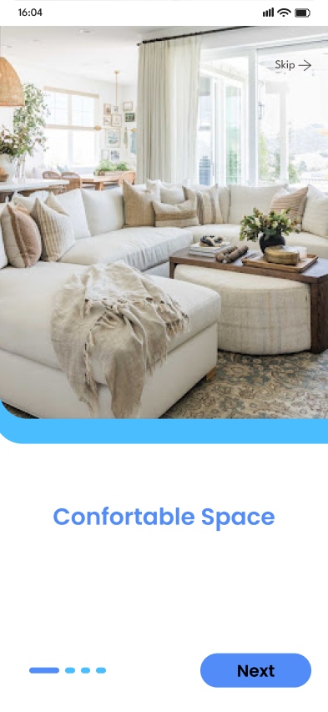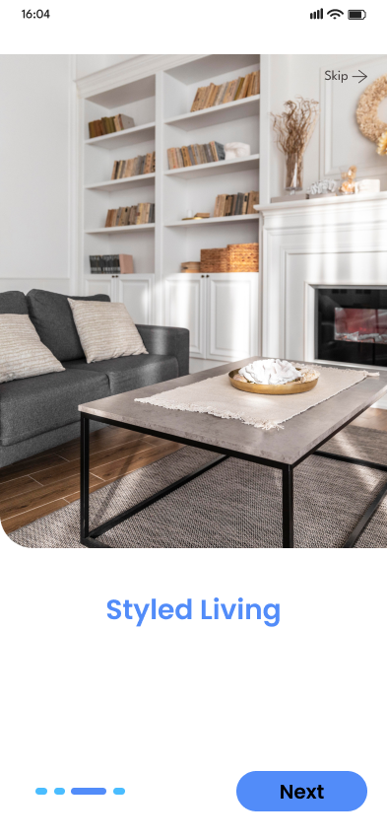

**2. Transform Every Room with Unique Styles**

We provide specialized design inspirations for every room, ensuring that each space is optimized for beauty and comfort.

* **Living Room:** Elevate your main gathering space with chic sofas, elegant coffee tables, stylish bookshelves, decorative wall art, and cozy rugs that tie everything together. Whether you prefer a **modern, Scandinavian, bohemian, or vintage aesthetic**, we have ideas to match every taste.
* **Bedroom:** Create a sanctuary of relaxation with premium bedding, sleek wardrobes, mood lighting, decorative pillows, and elegant headboards. Our guides help you achieve the perfect balance between **style and comfort**, ensuring a restful atmosphere.
* **Kitchen & Dining:** Upgrade your kitchen with modular cabinets, smart storage solutions, elegant countertops, and trendy backsplash designs. For the dining area, explore stylish dining sets, pendant lighting, and curated table decor that enhances mealtime aesthetics.
* **Office & Study Area:** Boost productivity with ergonomic furniture, minimalistic desks, practical shelving, and soft lighting that fosters focus and efficiency. Explore **modern, industrial, and cozy workspace designs** that blend functionality with elegance.
* **Bathroom & Spa Spaces:** Transform your bathroom into a personal retreat with luxurious bathtubs, stylish vanities, ambient lighting, and high-quality accessories for a spa-like experience

**3. Modern & Trendy Decor Elements**

Stay ahead of the latest home decor trends with designs that perfectly balance **elegance and practicality**. Whether you’re drawn to **luxurious furniture, statement lighting, bold colour palettes, or space-saving minimalist designs**, our collections offer inspiration for every aesthetic preference.

* **Smart Space-Saving Solutions:** Maximize small spaces with multi-functional furniture, hidden storage ideas, and minimalist layouts.
* **Eco-Friendly & Sustainable Decor:** Explore green decor solutions, including **indoor plants, sustainable furniture, and energy-efficient lighting**.
* **Accent Walls & Textures:** Add character to your interiors with textured wallpapers, creative paint patterns, and accent wall ideas that enhance the ambiance.
* **Lighting Trends:** From statement chandeliers to LED strips and pendant lights, find the perfect lighting to enhance your home’s mood and functionality.
* A screenshot of a cellphone

  Description automatically generatedScreenshot of a bed with blue squares and white text

  Description automatically generated

**4. Easy-to-Use & Intuitive Interface**

Navigating our website is a seamless experience! With a **user-friendly interface, interactive galleries, and intuitive browsing features**, finding your ideal home decor inspiration has never been easier.

**Our Features & Benefits**

* Stunning Visual Inspiration: Explore high-resolution images of beautifully designed interiors and decor setups.
* Personalized Recommendations: Get home decor ideas tailored to your preferences and living space.
* Step-by-Step Guides: Learn how to arrange furniture, select color palettes, and maximize space effectively.
* DIY Decor Projects: Discover creative and budget-friendly do-it-yourself home decor ideas.
* Trendy & Timeless Designs: Stay updated with the latest trends while exploring **everlasting classic styles**.

**Start Your Home Transformation Today!**

Let **Home Decor** be your trusted guide in designing and decorating your dream home. Whether you're moving into a new space, **renovating**, or simply refreshing your interiors, we have all the inspiration and tips you need to bring your vision to life.

* **🔹 Sign Up Now** to explore thousands of home decor inspirations!

